Relativity Dev VM

Create Windows Base Machine

Documentation

[September 28, 2019]

Table of Contents

1 Creating the VM 3

2 Windows Server Settings **Error! Bookmark not defined.**

3 Software to Install **Error! Bookmark not defined.**

4 Pin Applications to Taskbar **Error! Bookmark not defined.**

5 Chef Recipes to Run 27

6 Creating Base Image Box file 27

7 When Upgrading Base Image 27

# Creating the VM

1. Create the following folders on host machine
   1. **S:\DynamicDisk**
   2. **S:\DynamicVm\Hyper-V\Virtual Hard Disks**
   3. **S:\ISO**
2. Download **Windows Server 2016** ISO file at this link - <https://www.microsoft.com/en-us/evalcenter/evaluate-windows-server-2016>
3. Copy the downloaded ISO file to **S:\ISO** folder
4. Enable Hyper-V on the host machine.
5. Create an **External Hyper-V Virtual Switch** on the host machine. Name the switch as **Default Switch.**
6. Set **PowerShell** to always open with ‘**Run as Administrator**’ permissions.
7. Open Hyper-V Manager application.

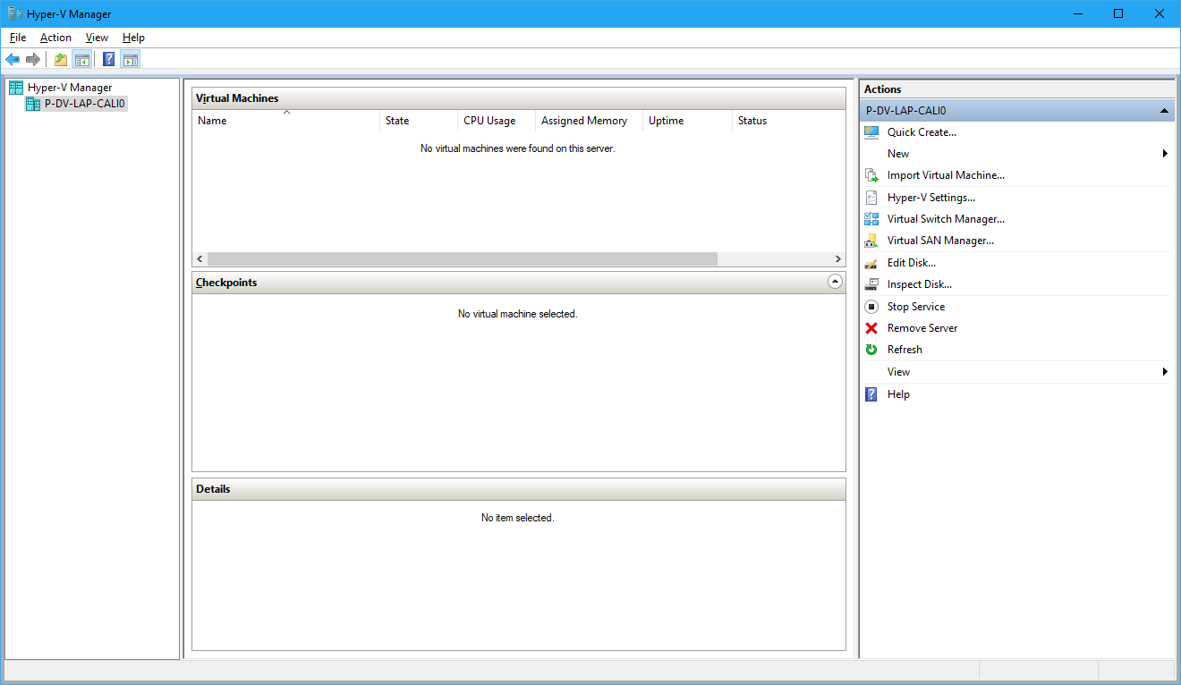

1. From the Actions window on the right side, Select New and then select Hard Disk option

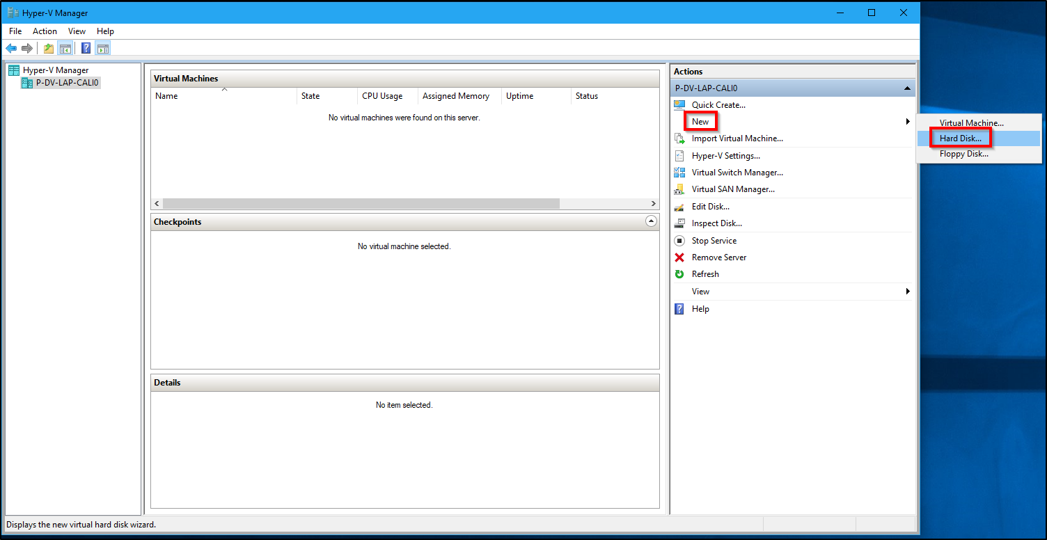

1. Click Next

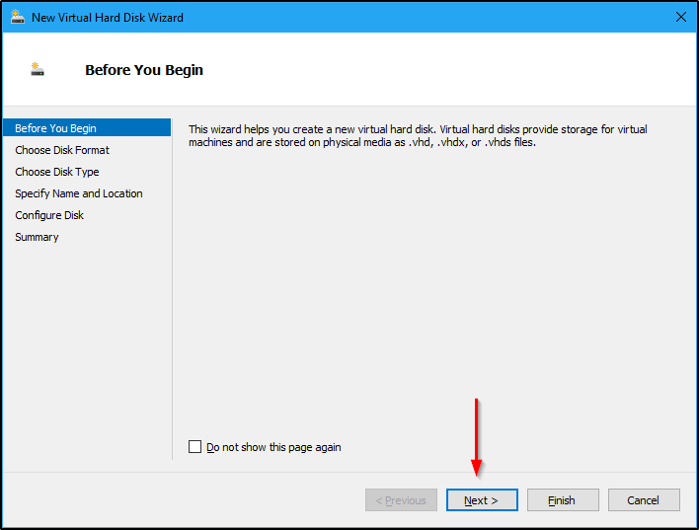

1. Select VHDX option and click Next

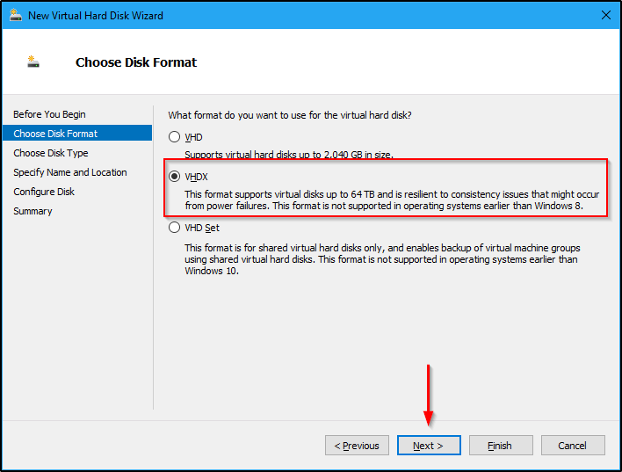

1. Select Dynamically expanding option and click Next

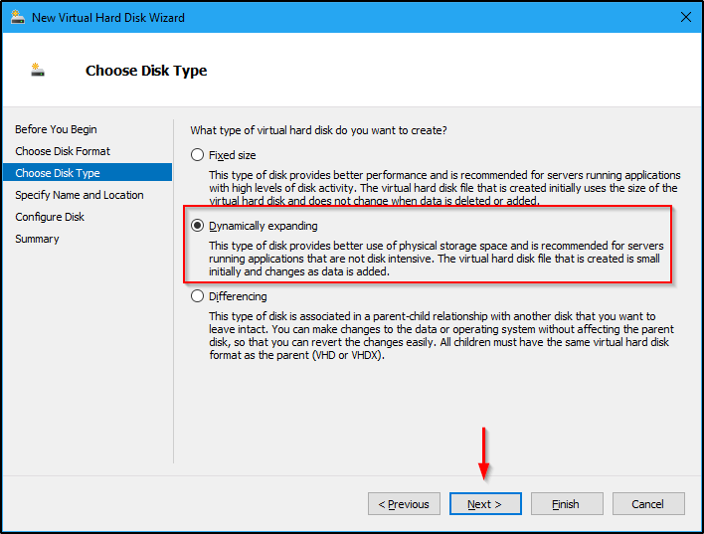

1. Enter a Name and Location for the new Virtual Hard disk and then click Next

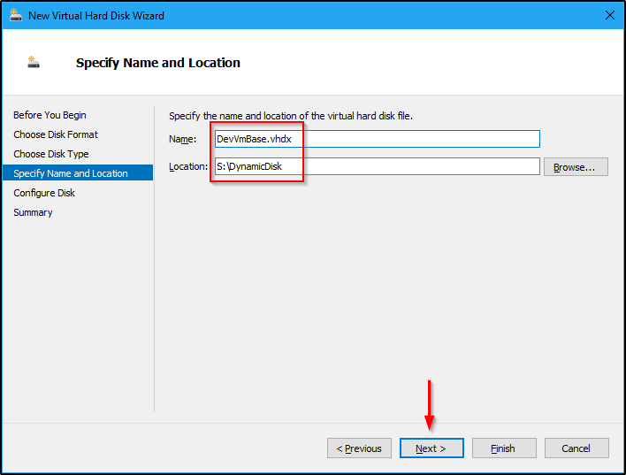

1. Enter the desired size in GB and then click Next

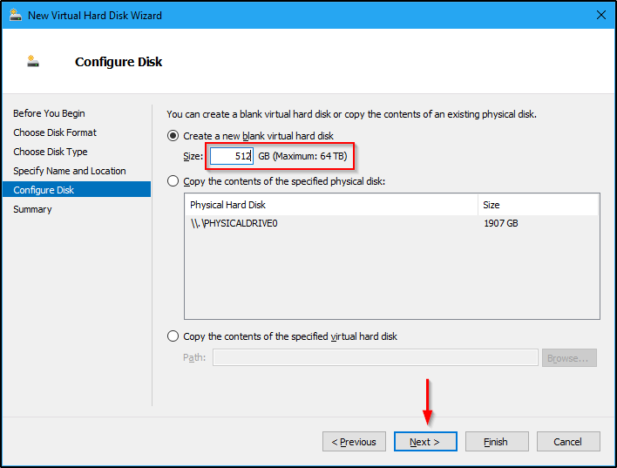

1. Click Finish

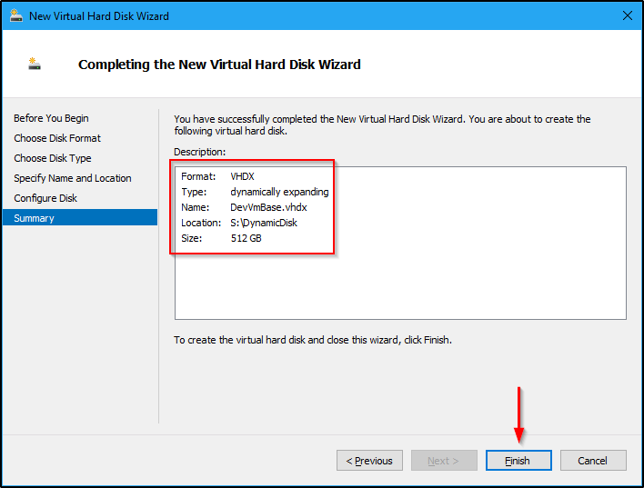

1. Verify if the Virtual Hard disk is created in the provided location.

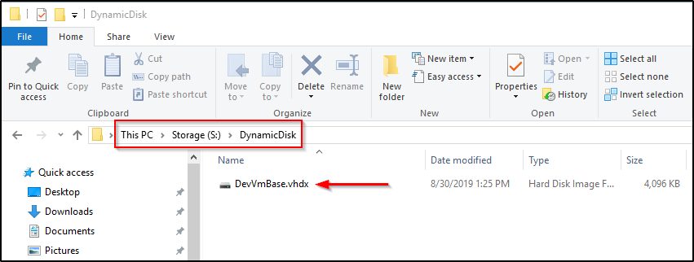

1. Copy the just created Virtual Hard disk from "S:\DynamicDisk\DevVmBase.vhdx" to "S:\DynamicVm\Hyper-V\Virtual Hard Disks\DevVmBase.vhdx" location.

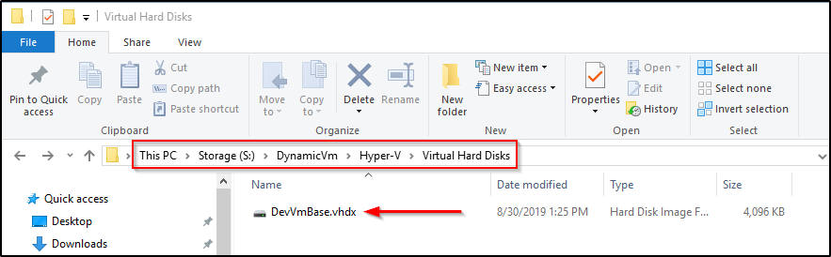

1. From the Actions window on the right side, Select New and then select Hard Disk option

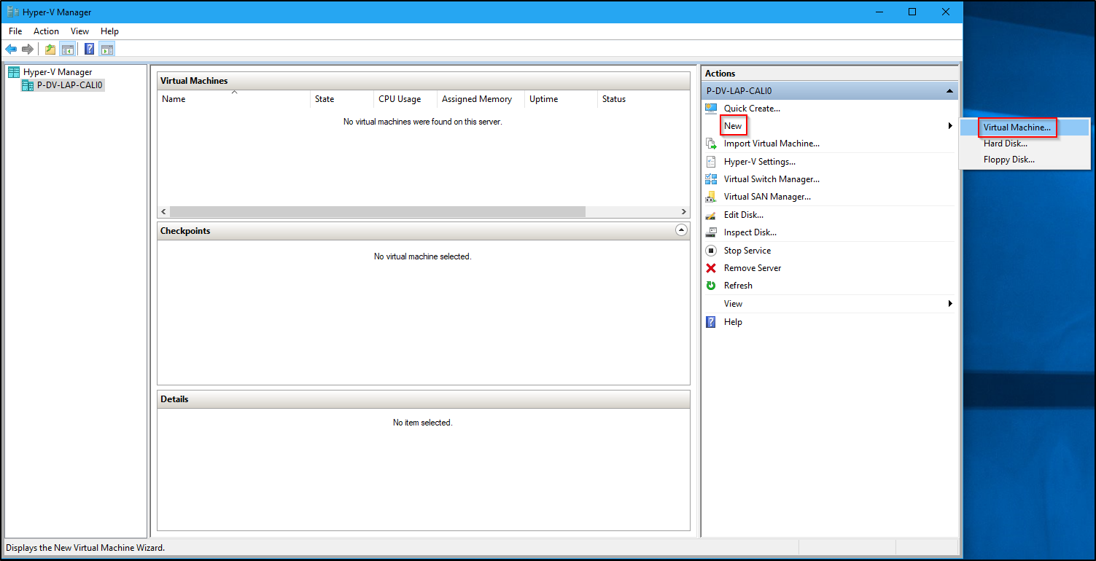

1. Click Next

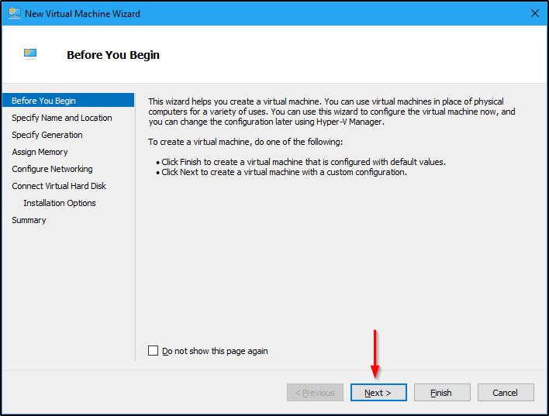

1. Provide a name and a location for the new Virtual machine

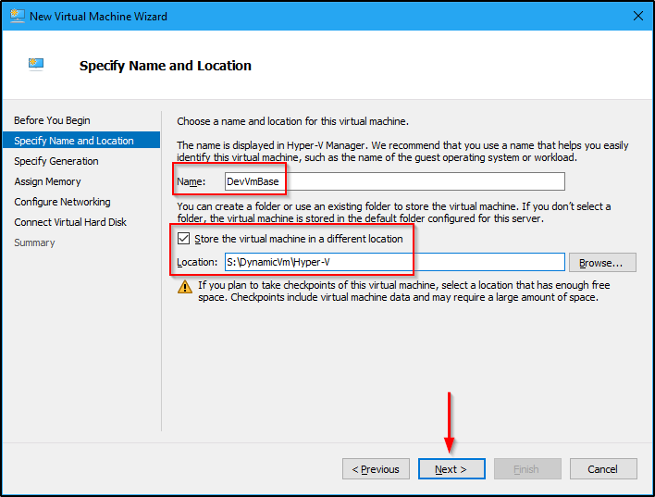

1. Pick Generation 2 and click Next

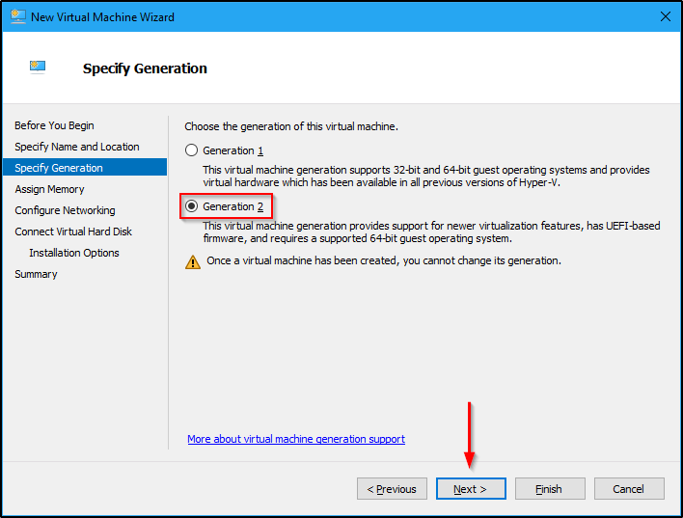

1. Provide the necessary memory and select Next. Also uncheck Dynamic Memory option.

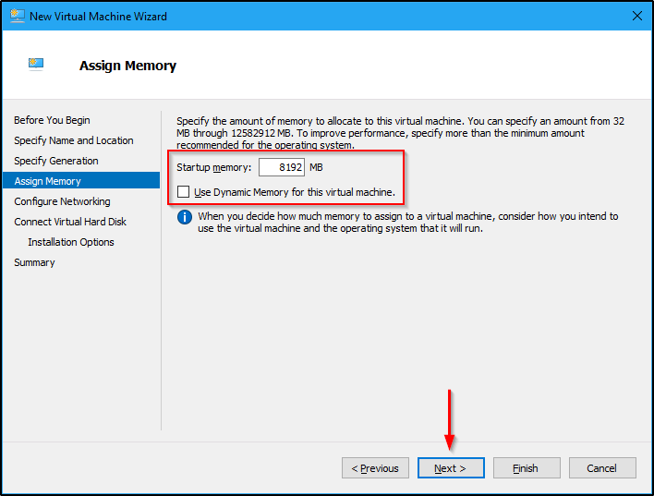

1. Select a Virtual Switch and click Next

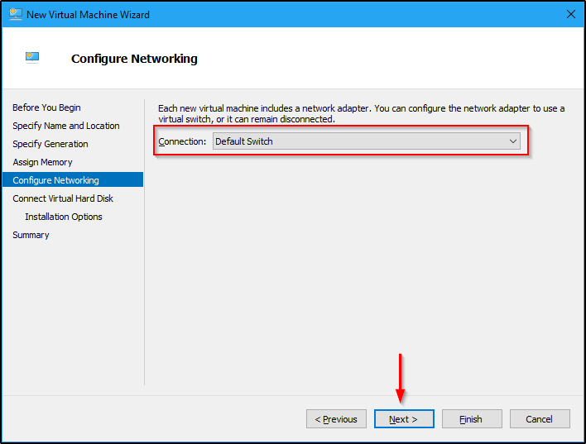

1. Select the Dynamic Virtual Hard Disk we created previously and select Next

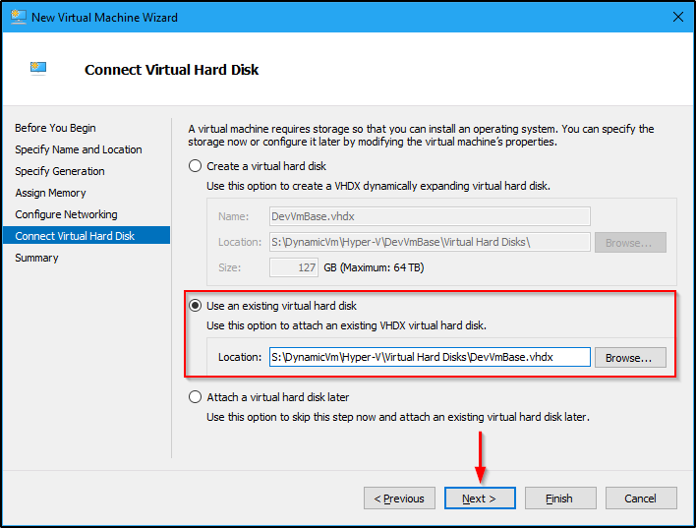

1. Click Finish

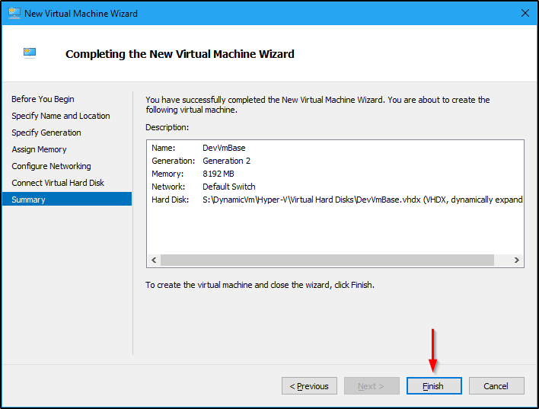

1. Confirm the VM is created

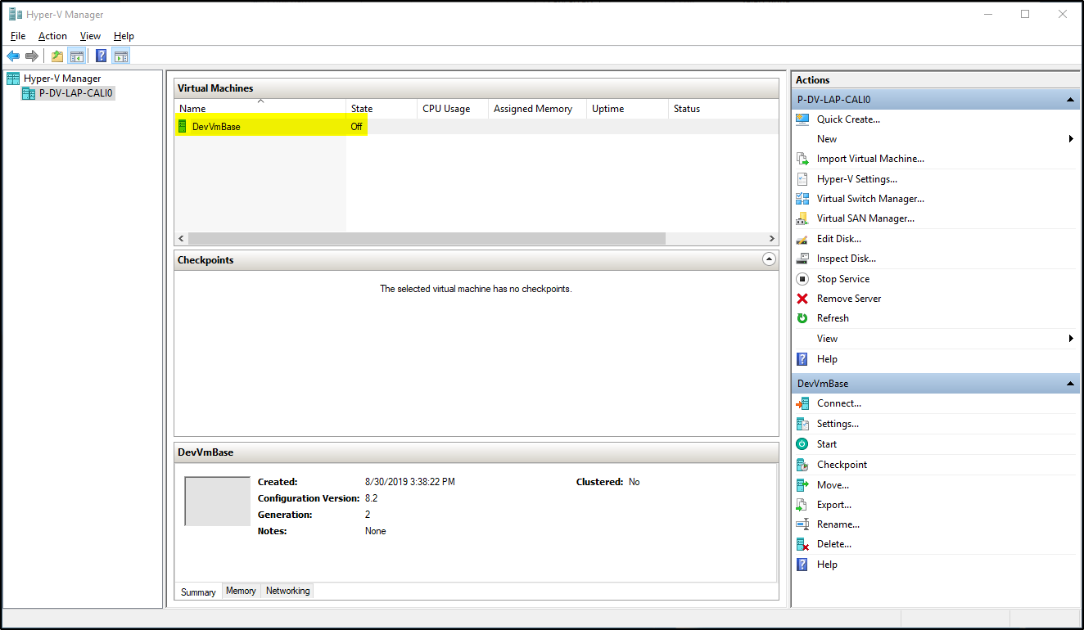

1. Right click on the VM and select Settings
2. Under SCSI Controller settings, select DVD Drive and click Add

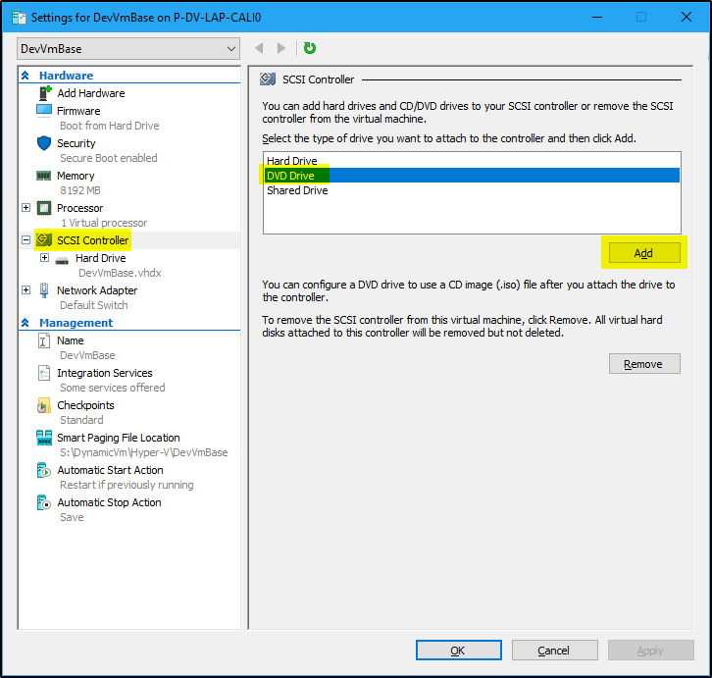

1. Select the ISO Image file you previously downloaded and click Apply. Then click Ok.

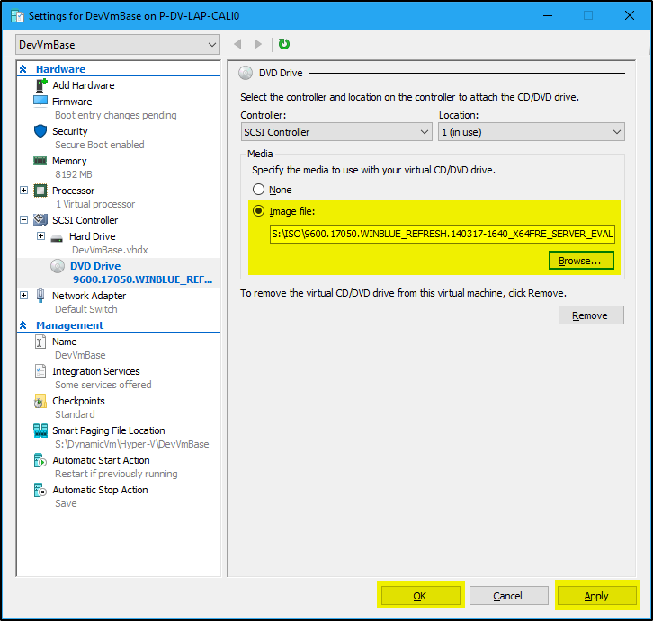

1. Then Click Ok
2. Also in the VM settings, turn off Automatic Checkpoints option.

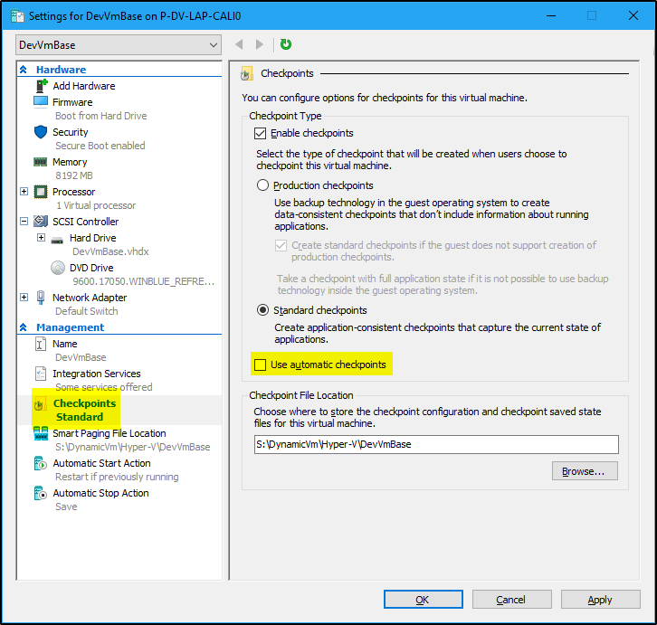

1. Next right click on the VM and start it.
2. During Windows Server OS installation, Choose the **Windows Server 2012 R2 Standard Evaluation (Server with a GUI)** option.

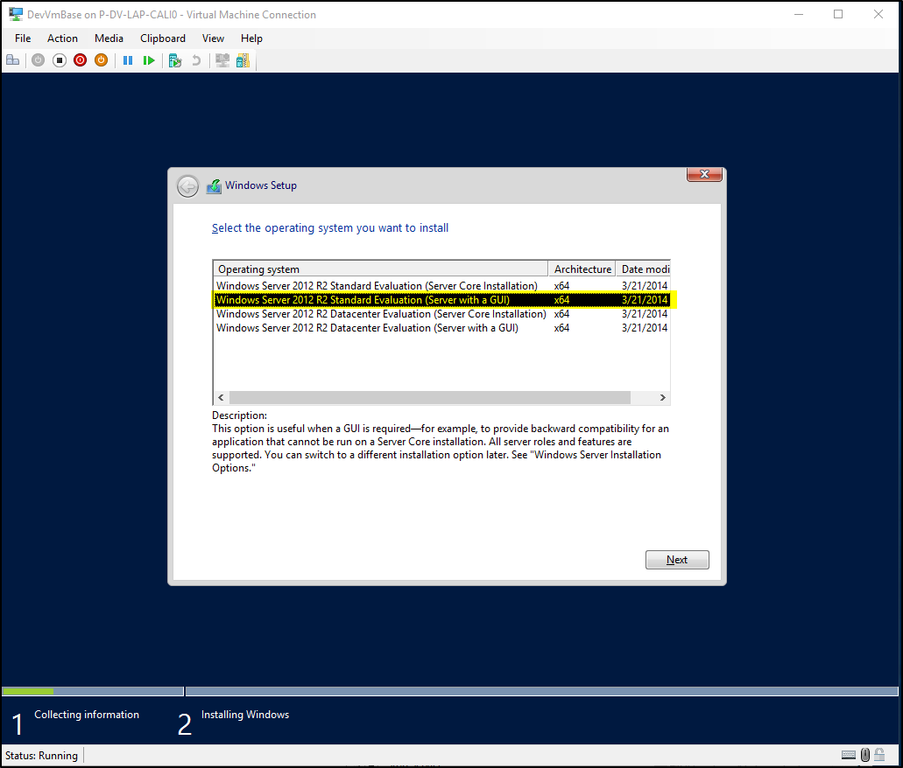

1. After the OS installation is successful, **Eject** the OS disk.
2. Share the host machine internet connection with the VM. (share it to **Default Switch**)
3. Change Computer Name and Description to **DevVmBase**
   1. Restart your VM
4. **Windows Explorer**
   1. Show hidden files
   2. Show extension for known file types
5. **Taskbar**
   1. Set to Never combine labels
6. Open Computer Management
   1. For Administrator user, set the **password to never expires**

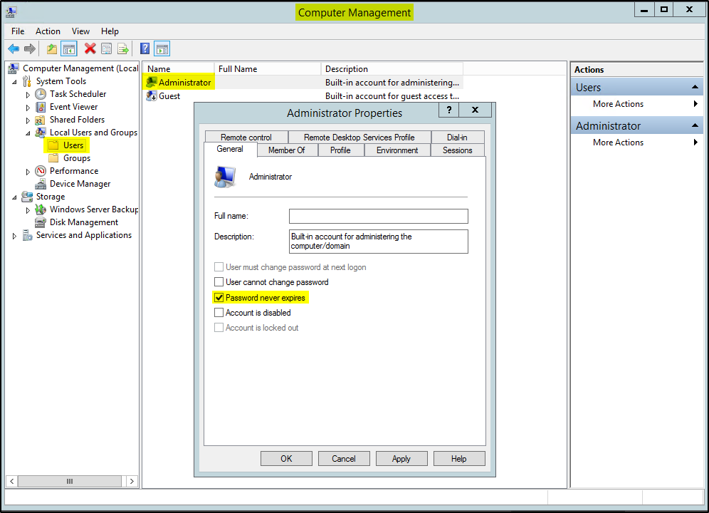

1. In **Server Manager** application
   1. Turn off **Firewall** (for Domain, Private and Public profiles)
   2. Enable **Remote Management**
   3. Enable **Remote Desktop** connections
      * Add current user (DevVmBase/Administrator) under **Select Users** button
   4. Remove **IPV6** for the **Ethernet** Network Adapter.
      * Right click on the Ethernet Adapter and uncheck **Internet Protocol Version 6 (TCP/IPv6)**
   5. Turn **IE Enhanced Security Configuration** Off.
      * Both for Administrators and Users
   6. Change **Windows Time zone** to **Central (US & Canada)** and turn **On** the **Set time zone automatically** setting.
2. Change PowerShell Execution Policy to Unrestricted by running the following command in PowerShell

Set-ExecutionPolicy Unrestricted

1. Set **PowerShell** to always **Run as Administrator**
2. Change **User Account Control** settings to **Never Notify**.
3. **Windows Updates**
   1. Turn on Automatic Updates.
   2. Install all available updates
4. Create **C:\Software_Install** folder.
5. Ninite
   1. Use **Ninite.com** for the following
      * 7 zip
      * Chrome
      * Notepad++
      * Visual Studio Code
      * WinDirStat
   2. **Rename** the exe to Ninite.exe
   3. **Copy** the Ninite.exe to this path on the VM - "**C:\Software_Install\Ninite.exe**"
   4. Also set Ninite to update software using Task Scheduler (<https://www.groovypost.com/howto/ninite-install-update-programs-automatically/>)
      * Set it to **run automatically** when the user **Logs in to the system**.
6. Download the following installers and copy to the **C:\Software_Install** folder on the VM and install them.
   1. Adobe Reader – Latest
   2. Java JDK – Latest (Don’t do Ninite JDK install)
7. SQL Server Management Studio - Latest
8. Visual Studio 2015 Remote Debugger - Latest and x64
9. Visual Studio 2017 Remote Debugger - Latest and x64
10. Visual Studio 2019 Remote Debugger - Latest and x64
11. Office 2010 Service Pack 2 (Install Office 2010 first)
12. Check the **PowerShell version** on the VM by running the following command

Get-Host | Select-Object Version

* 1. If the installed PowerShell version is not 5.1.x.x, Install **PowerShell 5.1**
     + Download and install [Win8.1AndW2K12R2-KB3191564-x64.msu](https://go.microsoft.com/fwlink/?linkid=839516) file at this link - <https://www.microsoft.com/en-us/download/details.aspx?id=54616>
     + Restart VM.

1. Check the .NET version **installed** on the VM is .NET **4.6.2** by running the following command in PowerShell. The value should be True.

Get-ChildItem 'HKLM:\SOFTWARE\Microsoft\NET Framework Setup\NDP\v4\Full\' | Get-ItemPropertyValue -Name Release | Foreach-Object { $_ -ge 394802 }

Reference: <https://docs.microsoft.com/en-us/dotnet/framework/migration-guide/how-to-determine-which-versions-are-installed#ps_a>

* 1. If the installed .NET version is not .NET 4.6.2 or higher, Install **.NET 4.6.2**
     + Download and install - <https://www.microsoft.com/en-us/download/details.aspx?id=53344>
     + Restart VM.

1. Install .Net 4.6.2 Developer Pack
   1. Download link - <https://www.microsoft.com/en-us/download/details.aspx?id=53321>
2. Delete any Install files from the **C:\Software_Install** (except for **Ninite** file) and **Recycle Bin** folders.
3. In Hyper-V Manager, turn off **Enable Dynamic Memory** settings
4. Setup **WinRM**
   1. Run the following commands in PowerShell

Get-NetFirewallPortFilter | ?{$_.LocalPort -eq 5985 } | Get-NetFirewallRule | ?{ $_.Direction -eq "Inbound" -and $_.Profile -eq "Public" -and $_.Action -eq "Allow"} | Set-NetFirewallRule -RemoteAddress "Any"

winrm quickconfig -q

winrm set winrm/config/winrs '@{MaxMemoryPerShellMB="512"}'

winrm set winrm/config '@{MaxTimeoutms="1800000"}'

winrm set winrm/config/service '@{AllowUnencrypted="true"}'

winrm set winrm/config/service/auth '@{Basic="true"}'

Start-Service WinRM

set-service WinRM -StartupType Automatic

1. Login into **SQL Server Management Studio** with **sa** login
   1. Select **Remember Password** option and click **Connect** to verify credentials are correct and are saved.

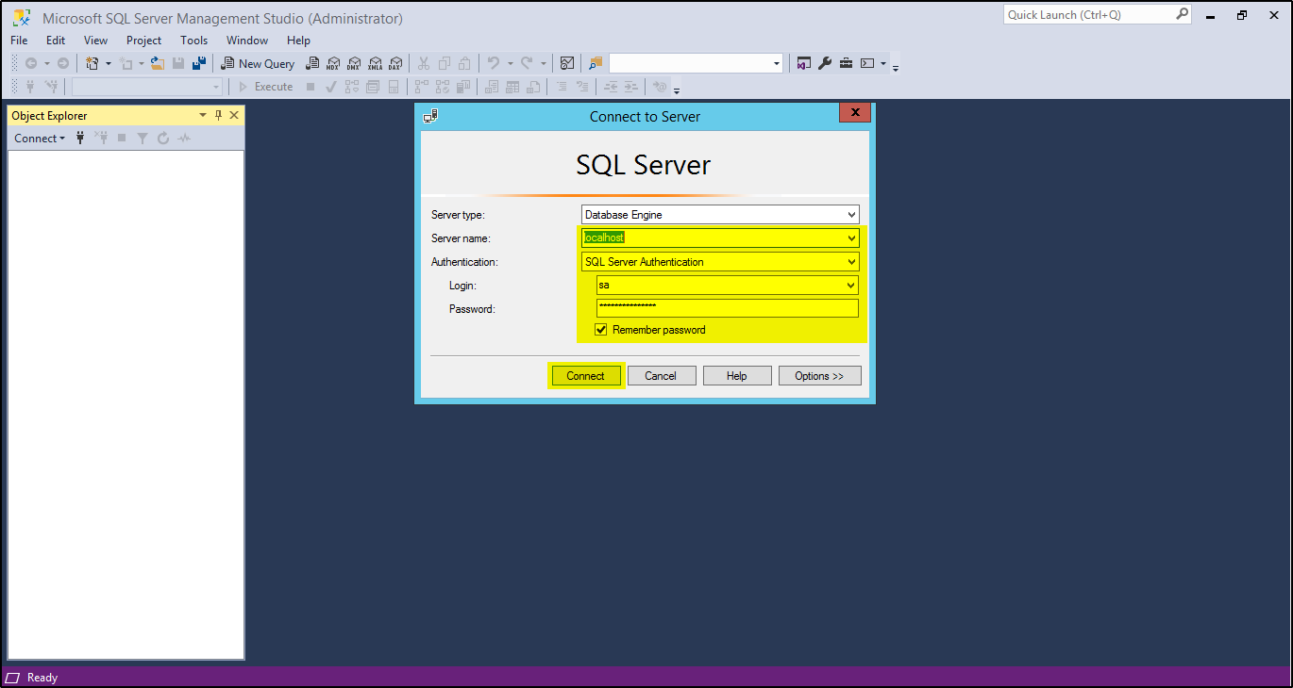

* 1. Change **Max allowed memory for SQL** server.
     + Right click on the server name (localhost) and select Properties
     + Go to memory settings and change **Maximum server Memory** (in MB) value to 6144 (6GB)

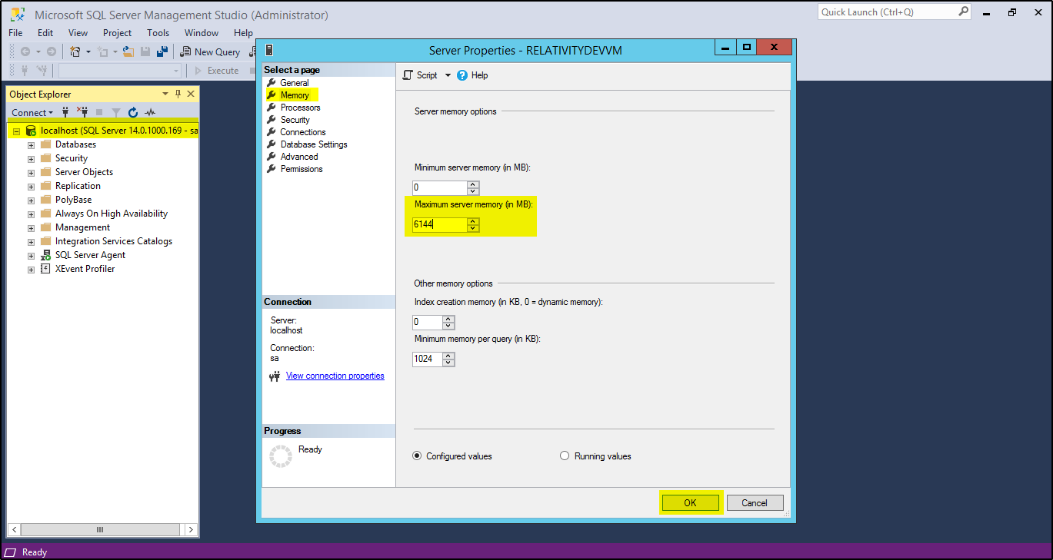

* + - Click OK
    - Restart the VM

1. Create a Relativity Login page Bookmark in Chrome
2. Delete all Desktop icons except for Recycle Bin.
3. Pin the following Applications to Taskbar
   1. Server Manager
   2. PowerShell
   3. Windows Explorer
   4. Chrome
   5. Visual Studio 2015 Remote Debugger
   6. Visual Studio 2017 Remote Debugger
   7. Visual Studio 2019 Remote Debugger
   8. Services
   9. Task Manager
   10. SQL Server Management Studio
   11. Notepad++

# Chef Recipes to Run

1. Chef - pre_windows_create_default_folders
2. Chef - pre_windows_install_nuget_provider
3. Chef - pre_windows_change_computer_name
4. Chef - windows_disable_firewall
5. Chef - windows_set_explorer_properties
6. Chef - windows_give_background_processes_priority
7. Chef - windows_set_auto_login
8. Chef - windows_install_software
9. Chef - windows_add_programs_to_taskbar
10. Chef - pre_relativity_install_windows_features_and_services
11. Chef - pre_relativity_create_shared_folders
12. Chef - pre_relativity_install_sqlserver
13. Chef - pre_relativity_install_servicebus

# Creating Base Image Box file

1. Reset Windows Server License to 180 days
2. Change Hardware resources to 2 cores and 8GB RAM before exporting
3. Export VM
4. Convert to .box file

# When Upgrading Base Image

1. Reset the Windows Server 6-month trial license
2. Install Latest Windows Updates
3. Run Latest Ninite from this path - **"C:\Software_Install\Ninite.exe"**